

**DATABASE DESIGN**

The ***BookItDB*** database is designed to manage the operations of an Automated Meeting Room Booking System. It consists of the following key entities:

* **Users**: Stores user-related information, including roles and credentials.
* **Rooms**: Contains details of the meeting rooms available for booking.
* **Amenities**: Lists the amenities available in the rooms, along with associated costs.
* **Meetings**: Manages the scheduling of meetings and associated room bookings.

**RELATIONSHIP DIAGRAM**

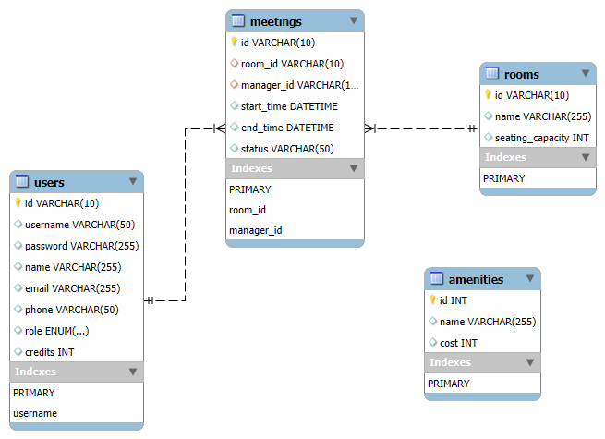

1. **USERS TABLE**

**Purpose**: This table stores information about the users of the system, including their credentials, contact information, and roles.

**Table Structure**:

| **Attribute** | **Data Type** | **Description** |
| --- | --- | --- |
| id | VARCHAR(10) | Primary Key, Unique identifier for each user |
| username | VARCHAR(50) | Unique username for the user |
| password | VARCHAR(255) | Encrypted password for the user |
| name | VARCHAR(255) | Full name of the user |
| email | VARCHAR(255) | Email address of the user |
| phone | VARCHAR(50) | Phone number of the user |
| role | ENUM('Admin', 'Manager', 'Member') | Role of the user within the system |
| credits | INT | Credits available to the user for booking |

**Explanation**:

* role indicates the user's level of access within the system.
* credits can be used to track a manager’s booking balance or allowance.

1. **ROOMS TABLE**

**Purpose**: This table maintains records of all meeting rooms available within the system.

**Table Structure**:

| **Attribute** | **Data Type** | **Description** |
| --- | --- | --- |
| id | VARCHAR(10) | Primary Key, Unique identifier for each room |
| name | VARCHAR(255) | Name of the meeting room |
| seating_capacity | INT | Seating capacity of the meeting room |

**Explanation**:

* The seating_capacity attribute allows users to select a room that meets the requirements of their meeting size.

1. **AMENITIES TABLE**

**Purpose**: This table lists all the amenities available in the meeting rooms, along with their associated costs.

**Table Structure**:

| **Attribute** | **Data Type** | **Description** |
| --- | --- | --- |
| id | INT AUTO_INCREMENT | Primary Key, Unique identifier for each amenity |
| name | VARCHAR(255) | Name of the amenity |
| cost | INT | Cost associated with the amenity |

**Explanation**:

* The cost attribute helps in calculating the total cost of booking a room with specific amenities.

1. **MEETINGS TABLE**

**Purpose**: This table manages the scheduling and status of meetings, including which room is booked and which user is responsible for managing the meeting.

**Table Structure**:

| **Attribute** | **Data Type** | **Description** |
| --- | --- | --- |
| id | VARCHAR(10) | Primary Key, Unique identifier for each meeting |
| room_id | VARCHAR(10) | Foreign Key, References Rooms(id) |
| manager_id | VARCHAR(10) | Foreign Key, References Users(id) |
| start_time | DATETIME | Start time of the meeting |
| end_time | DATETIME | End time of the meeting |
| status | VARCHAR(50) | Current status of the meeting |

**Explanation**:

* room_id links the meeting to a specific room.
* manager_id identifies the user responsible for managing the meeting.
* status could indicate whether the meeting is scheduled, in progress, or completed.